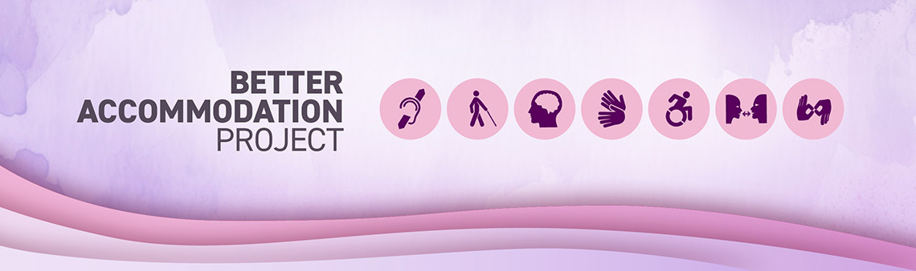

What’s next for the Better Accommodation Project

Overview
The Better Accommodation Project (BAP) was launched to drive substantive and impactful change in how departments provide workplace accommodation to employees with disabilities. It involved nine departments and the Privy Council Office’s Impact and Innovation Unit and resulted in the development of tools and resources for all federal departments and agencies. Once fully implemented, these tools will help organizations build more inclusive workplaces by eliminating barriers faced by employees with disabilities in a more timely, effective and efficient way.

Next steps (Fall 2025 – March 2026):
As of October 2025, the BAP team will begin shifting its focus to supporting departments and agencies to embed and use the BAP tools and resources.
Specifically, they will:
- Share BAP tools by engaging with functional communities across the federal government responsible for:
- Human resources;
- Information technology;
  - Procurement;
- Real property management;
  - Audit and Evaluation; and
- Experts leading the development and implementation of accessibility, diversity and inclusion plans
- Provide support and advice to departments and agencies to include BAP best practices in their accessibility plans and workplace accommodation processes.
- Support Implementation Partner departments to continue to prototype process improvements and solutions (e.g., Transport Canada is testing a chatbot and developing an integrated case management system) that could be leveraged by all organizations.

Beyond BAP: Opportunities for future progress
The Better Accommodation Project revealed areas of work that could be explored collectively or by individual departments to support ongoing improvements to workplace accommodation for federal employees with disabilities. These areas include:

Continued prototyping and scaling up promising prototypes
- Scale up prototypes developed by Implementation Partner departments.
- Evaluate effectiveness and adaptability across different organizations.

Economic analysis
- Conduct further research into the costs and benefits of workplace accommodation service delivery in the public service.
- Develop a business case to support sustained investment in inclusive workplace practices.

Intersectional insights
- Deepen understanding of how employees with intersectional identities (e.g. race, gender, disability, Indigeneity, 2SLGBTQI+ status) experience workplace accommodation.
- Use findings to inform more responsive workplace accommodation policies.

Policy and process modernization
The results of the BAP initiative can also inform work being undertaken by individual departments or federal organizations with enterprise-wide responsibilities. Specifically, while we need to address barriers that exist, we also want to avoid creating new ones for employees with disabilities. That means applying a disability inclusion lens all the time, including when developing new policy or updating existing ones.

5. Continued evolution of the BAP tools
With the widespread adoption of the BAP tools, opportunities will arise to further refine and improve them. Feedback from employees and those delivering workplace accommodation services will be an important element of the go forward plan. Any adjustments to the tools should be shared, so that all departments can benefit.

Conclusion
The Government of Canada has learned from the Better Accommodation Project. Moving forward, departments and agencies that implement the BAP tools will be well-positioned to drive systemic change in how the federal public service approaches workplace accommodation for employees with disabilities.

